https://www.nlog.nl/nlog-mapviewer/brh/2415622160?lang=nl
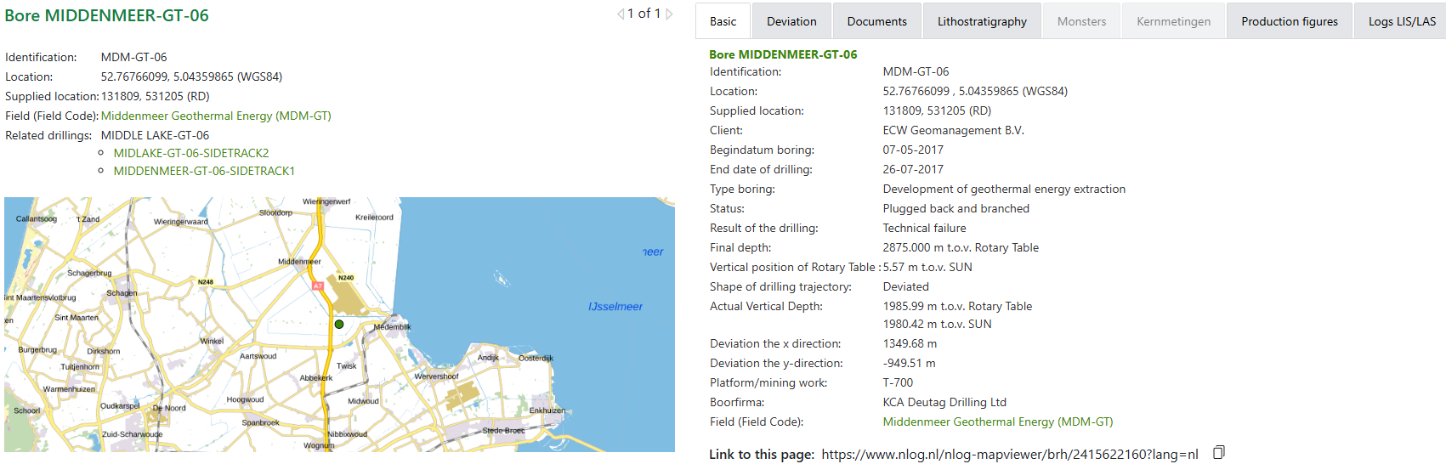
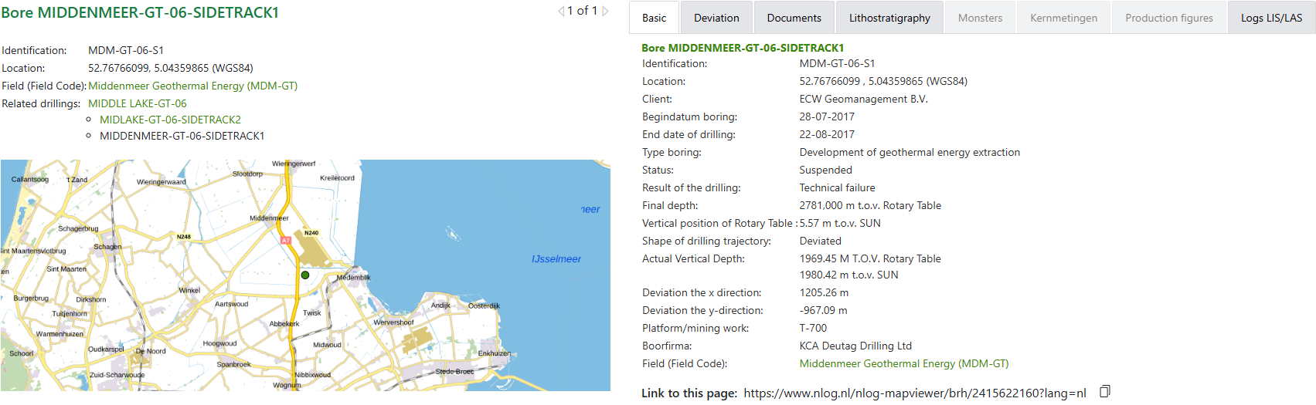
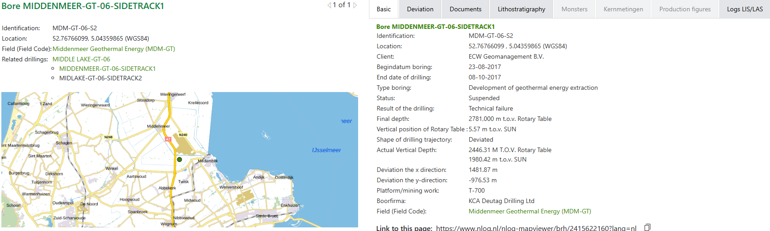

Boring MIDDENMEER-GT-06
Categorie | Document
Borehole/Well - Final Report | End of Well Report - Drilling(31 Oct 2017)
Documents with borehole measurements | Technical Log(0-2875)(26 Jul 2017)

Bore MIDDENMEER-GT-06-SIDETRACK1
Categorie | Document
Borehole/Well - Final Report | End of Well Report - Drilling(31 Oct 2017)
Documents with borehole measurements | Technical Log(0-2781)(22 Aug 2017)

Bore MIDDENMEER-GT-06-SIDETRACK2
Categorie | Document
Borehole/Well - Final Report | End of Well Report - Drilling(31 Oct 2017)
Documents with borehole measurements | Technical Log(0-3278)(23 Aug 2017)

